实验二 面向对象分析与类图设计（4学时）
课 程 | 面向对象分析与设计 | 实验项目 | 类图设计-1 | 成 绩
专业年级 | 软件工程2017 | 指导教师 | 王世元 | 实验日期 | 2019.6.2
姓 名 | 陈东 | 学 号 | 201731062232
姓 名 | 沈瑞琦 | 学 号 | 201731062229
姓 名 | 刘平 | 学 号 | 201731062233
姓 名 | 卿梦成 | 学 号 | 201731062215
实验目的及要求：
目的：学会类图的绘制，学会利用面向对象的思想分析相关业务域问题。
要求：
- 学会绘制类图
- 深刻理解面向对象思想中的封装、继承、与多态
- 学会应用相关面向对象思想分析实际业务领域的问题
- 能够将面向对象分析的过程，编码加以具体实现，在实践中加深理解
说明：
- Power Point软件中的“插入几何图形功能”为PPT的制作提供了很大的帮助，功能丰富，应用广泛。请参照上述功能，利用所学的面向对象分析的思想，结合C#语言，以及GDI+ API模仿实现上述功能。具体要求如下：
- 首先简要文字描述，你的软件包含的插入几何图形的功能。例如：可以插入那些种类的图形，图形是否包含边框，图形是否包含问题，图形是否包含图片，纹理，渐变等等。基本要求（60分）：包含矩形，椭圆，三角形，直线的绘制。几何图元包含边框，边框可以设置粗细颜色以及虚线形式。几何图元内部可以包含文672C ，文本可以设置字体，颜色等。
- 根据对应功能，绘制UML类图。要求类的设计合理，结构清晰，可扩展性强。
- 根据绘制的类图，利用C#语言，以及GDI+ API实际编写代码实现上述功能。代码编写正确，可读性强。

实验内容：
- 简要描述你准备编写的软件的基本功能
实现类似Power Point的添加不同的图形的功能，可以添加底色为纯色或者渐变底色的矩形，可以添加三角形，椭圆，直线，矩形图片。可以自定义边框颜色、粗细，可以自定义图形底色，可以在图形上添加文字并可以自定义文字字体、大小、颜色。

- 相关类图
- 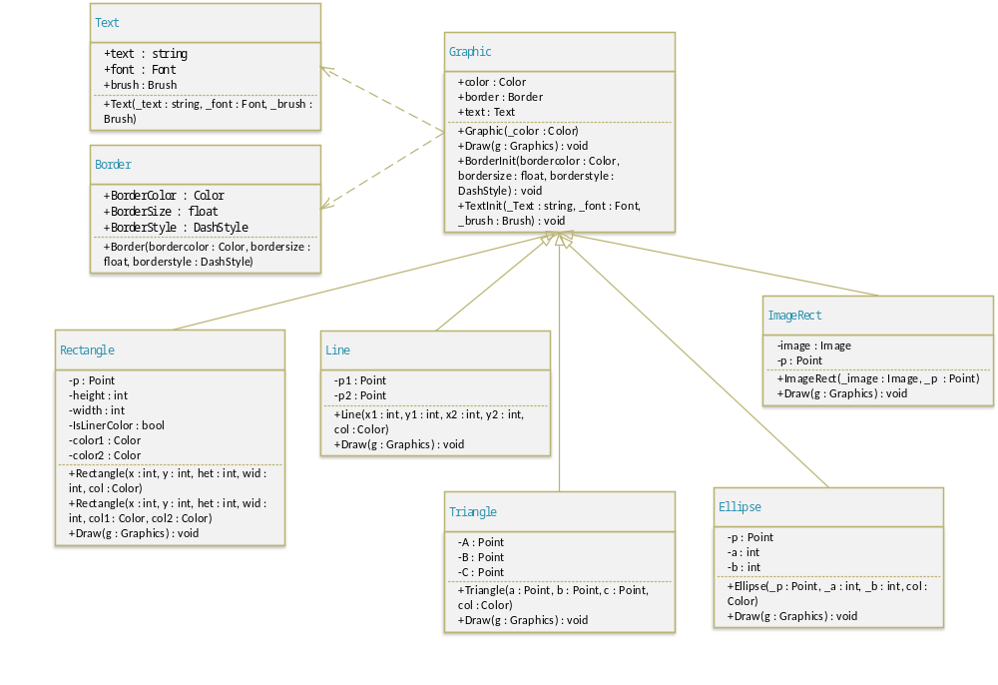具体代码贴图以及软件功能展示截图
绘制一系列矩形，可以修改边框类型、粗细，底色或开启渐变
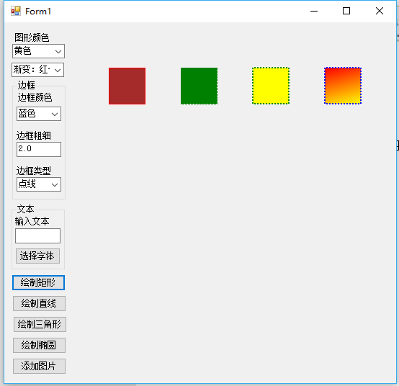

绘制一系列直线，可以修改颜色、粗细、类型
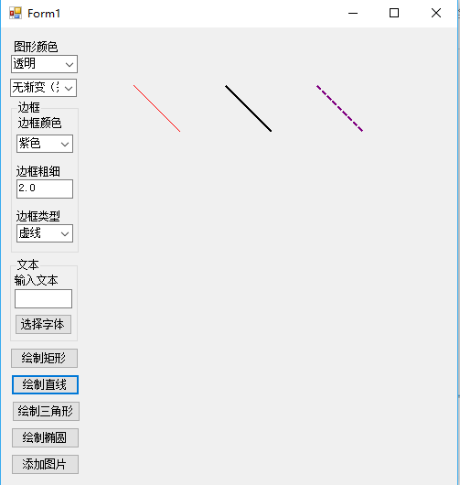
添加一系列三角形，可以修改边框类型、粗细，底色
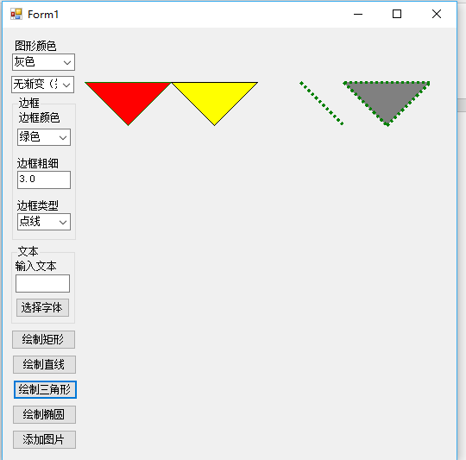
绘制一系列椭圆，可以修改边框类型、粗细，底色
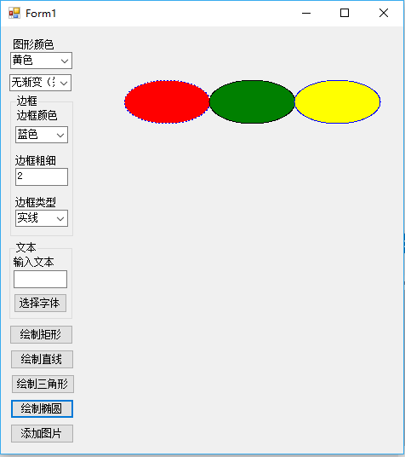

插入图片，可以设置边框类型
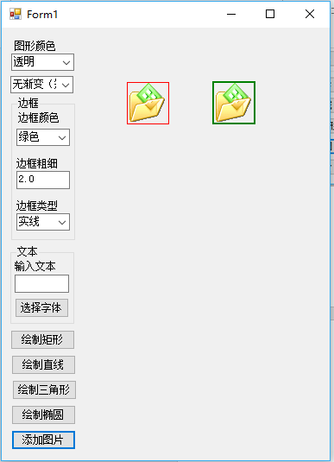
在图形上添加文字，可以设置字体，大小，粗细
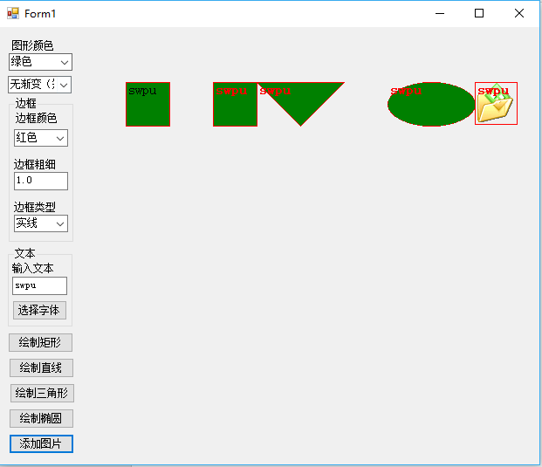

代码：
using System;
using System.Collections.Generic;
using System.ComponentModel;
using System.Data;
using System.Drawing;
using System.Drawing.Drawing2D;
using System.Linq;
using System.Text;
using System.Threading.Tasks;
using System.Windows.Forms;

namespace uml2
{
public partial class Form1 : Form
{
private int i = 0;
private List<Color> bordercolors = new List<Color>() { Color.Red, Color.Blue, Color.Black, Color.Green, Color.Purple, Color.White, Color.Gray };
private List<DashStyle> borderstyles = new List<DashStyle>() { DashStyle.Solid, DashStyle.Dash, DashStyle.Dot };
private Font selectedFont = new Font("Consolas", 17);
private SolidBrush selectedFontColor = new SolidBrush(Color.Black);
private List<Color> grapiccolor = new List<Color>() { Color.Transparent, Color.Black, Color.Brown, Color.Red, Color.Yellow, Color.Green, Color.Gray };
private List<Graphic> graphics = new List<Graphic>();
public Form1()
{
InitializeComponent();
comboBox1.SelectedIndex = 0;
comboBox2.SelectedIndex = 0;
comboBox3.SelectedIndex = 0;
comboBox4.SelectedIndex = 0;
}

private void button1_Click(object sender, EventArgs e) //绘制矩形
{
Graphics g = panel1.CreateGraphics();
Rectangle rectangle = null;
if (comboBox4.SelectedIndex == 0) rectangle = new Rectangle(50 + 100 * (i++), 50, 50, 50, grapiccolor[comboBox3.SelectedIndex]);
else if(comboBox4.SelectedIndex == 1) rectangle = new Rectangle(50 + 100 * (i++), 50, 50, 50, Color.Red, Color.Green);
else if(comboBox4.SelectedIndex == 2) rectangle = new Rectangle(50 + 100 * (i++), 50, 50, 50, Color.Red, Color.Yellow);
else if(comboBox4.SelectedIndex == 3) rectangle = new Rectangle(50 + 100 * (i++), 50, 50, 50, Color.Yellow, Color.Blue);
rectangle.BorderInit(bordercolors[comboBox1.SelectedIndex], float.Parse(textBox1.Text), borderstyles[comboBox2.SelectedIndex]);
rectangle.TextInit(textBox2.Text, selectedFont, selectedFontColor);
rectangle.Draw(g);
}

private void button2_Click(object sender, EventArgs e) //设置字体
{
fontDialog1.ShowColor = true;
fontDialog1.ShowDialog();
selectedFont = fontDialog1.Font;
selectedFontColor.Color = fontDialog1.Color;
}

private void button3_Click(object sender, EventArgs e) //绘制直线
{
Graphics g = panel1.CreateGraphics();
Line line = new Line(50 + 100 * i, 50, 100 + 100 * (i++), 100, grapiccolor[comboBox3.SelectedIndex]);
line.BorderInit(bordercolors[comboBox1.SelectedIndex], float.Parse(textBox1.Text), borderstyles[comboBox2.SelectedIndex]);
line.TextInit(textBox2.Text, selectedFont, selectedFontColor);
line.Draw(g);
}

private void button4_Click(object sender, EventArgs e) //绘制三角形
{
Graphics g = panel1.CreateGraphics();
Triangle triangle = new Triangle(new Point(50 + 100 * i, 100), new Point(100 + 100 * i, 50), new Point(0 + 100 * (i++), 50), grapiccolor[comboBox3.SelectedIndex]);
triangle.BorderInit(bordercolors[comboBox1.SelectedIndex], float.Parse(textBox1.Text), borderstyles[comboBox2.SelectedIndex]);
triangle.TextInit(textBox2.Text, selectedFont, selectedFontColor);
triangle.Draw(g);
}

private void button5_Click(object sender, EventArgs e) //绘制椭圆
{
Graphics g = panel1.CreateGraphics();
Ellipse ellipse = new Ellipse(new Point(50 + 100 * (i++), 50), 100, 50, grapiccolor[comboBox3.SelectedIndex]);
ellipse.BorderInit(bordercolors[comboBox1.SelectedIndex], float.Parse(textBox1.Text), borderstyles[comboBox2.SelectedIndex]);
ellipse.TextInit(textBox2.Text, selectedFont, selectedFontColor);
ellipse.Draw(g);
}

private void button6_Click(object sender, EventArgs e) //绘制图片
{
if(openFileDialog1.ShowDialog() == DialogResult.OK)
{
string file = openFileDialog1.FileName;
Image image = Image.FromFile(file);
Graphics g = panel1.CreateGraphics();
ImageRect imageRect = new ImageRect(image, new Point(50 + 100 * (i++), 50));
imageRect.BorderInit(bordercolors[comboBox1.SelectedIndex], float.Parse(textBox1.Text), borderstyles[comboBox2.SelectedIndex]);
imageRect.TextInit(textBox2.Text, selectedFont, selectedFontColor);
imageRect.Draw(g);
}
}
}
public class Text
{
public string text;
public Font font;
public Brush brush;
public Text(string _text, Font _font, Brush _brush)
{
text = _text;
font = _font;
brush = _brush;
}
}
public class Border
{
public Color BorderColor;
public float BorderSize;
public DashStyle BorderStyle;
public Border(Color bordercolor, float bordersize, DashStyle borderstyle)
{
BorderColor = bordercolor;
BorderSize = bordersize;
BorderStyle = borderstyle;
}
}
public abstract class Graphic //Graphic图形基类
{
public Color color;
public Border border;
public Text text;
public Graphic(Color _color)
{
color = _color;
border = new Border(Color.Red, 1.0f, DashStyle.Solid);
text = new Text("", new Font("Consolas", 17), Brushes.Black);
}
public abstract void Draw(Graphics g);
public void BorderInit(Color bordercolor, float bordersize, DashStyle borderstyle)
{
border.BorderColor = bordercolor;
border.BorderSize = bordersize;
border.BorderStyle = borderstyle;
}
public void TextInit(string _Text, Font _font, SolidBrush _brush)
{
text.text = _Text;
text.font = _font;
text.brush = _brush;
}
}
public class Rectangle : Graphic //Rectangle矩形类
{
private Point p;
private int height, width;
private bool IsLinerColor;
Color color1, color2;
public Rectangle(int x, int y, int het, int wid, Color col) : base(col)
{
p = new Point(x, y);
height = het;
width = wid;
IsLinerColor = false;
}
public Rectangle(int x, int y, int het, int wid, Color col1, Color col2) : base(Color.Transparent)
{
p = new Point(x, y);
height = het;
width = wid;
color1 = col1;
color2 = col2;
IsLinerColor = true;
}
public override void Draw(Graphics g)
{
Pen pen = new Pen(border.BorderColor, border.BorderSize);
pen.DashStyle = border.BorderStyle;
if(IsLinerColor)
{
LinearGradientBrush lgb = new LinearGradientBrush(new RectangleF(p.X, p.Y, width, height), color1, color2, 75f);
g.FillRectangle(lgb, new RectangleF(p.X, p.Y, width, height));
}
else g.FillRectangle(new SolidBrush(color), new RectangleF(p.X, p.Y, width, height));
g.DrawRectangle(pen, p.X, p.Y, height, width);
g.DrawString(text.text, text.font, text.brush, p);
g.DrawString(text.text, text.font, text.brush, p);
g.DrawString(text.text, text.font, text.brush, p);
g.DrawString(text.text, text.font, text.brush, p);
}
}
public class Line : Graphic //Line直线类
{
private Point p1, p2;
public Line(int x1, int y1, int x2, int y2, Color col) : base(col)
{
p1 = new Point(x1, y1);
p2 = new Point(x2, y2);
}
public override void Draw(Graphics g)
{
Pen pen = new Pen(border.BorderColor, border.BorderSize);
pen.DashStyle = border.BorderStyle;
g.DrawLine(pen, p1, p2);
g.DrawString(text.text, text.font, text.brush, p1);
}
}
public class Triangle : Graphic //Triangle三角形类
{
private Point A, B, C;
public Triangle(Point a, Point b, Point c, Color col) : base(col)
{
A = a;
B = b;
C = c;
}
public override void Draw(Graphics g)
{
Pen pen = new Pen(border.BorderColor, border.BorderSize);
pen.DashStyle = border.BorderStyle;
PointF[] points = { A, B, C};
g.FillPolygon(new SolidBrush(color), points);
g.DrawLine(pen, A, B);
g.DrawLine(pen, B, C);
g.DrawLine(pen, C, A);
g.DrawString(text.text, text.font, text.brush, C);
}
}
public class Ellipse : Graphic //Ellipse椭圆类
{
private Point p;
private int a, b;
public Ellipse(Point _p, int _a, int _b, Color col) : base(col)
{
p = _p;
a = _a;
b = _b;
}
public override void Draw(Graphics g)
{
Pen pen = new Pen(border.BorderColor, border.BorderSize);
pen.DashStyle = border.BorderStyle;
g.DrawEllipse(pen, p.X, p.Y, a, b);
g.FillEllipse(new SolidBrush(color), p.X, p.Y, a, b);
g.DrawString(text.text, text.font, text.brush, p.X, p.Y);
}
}
public class ImageRect : Graphic //ImageRect图像类
{
private Image image;
private Point p;
public ImageRect(Image _image, Point _p) : base(Color.Transparent)
{
image = _image;
p = _p;
}
public override void Draw(Graphics g)
{
Pen pen = new Pen(border.BorderColor, border.BorderSize);
pen.DashStyle = border.BorderStyle;
g.DrawImage(image, p.X, p.Y);
g.DrawRectangle(pen, p.X, p.Y, image.Width, image.Height);
g.DrawString(text.text, text.font, text.brush, p.X, p.Y);
}
}
}

